Super Ecchi TRPG (Insert name here)

Story

* Salamander Cave - NON NEGOTIABLE
* At start of story, give the player 3 character create tokens (Power Cells?) so they can create some basic characters

Characters

* Jar-jar the Milkable Salamander

Level/Environment Design

* Out of Battle
  + Chapter Select
    - List of available maps/missions
    - Chapters -> missions in that chapter
    - Each chapter is themed
    - Selecting a chapter gives flavor text about the chapter
    - Selecting a mission gives flavor text about the map/mission
    - Once a mission is selected, it loads that Battle Stage
  + Character Screen/Barracks
    - Check stats
    - Equip gear
    - Reorder/Organize party
    - Character create
  + Shop/Forge/Exchange/Hearth/etc
    - Buy/Sell items
    - Create items
    - COOKING YAAAAASSSS
  + Options Menu
    - Credits
    - Sound
    - Difficulty
    - Save/Load (LOL stretch goal ; 3 ;)
* Battle Stages
  + Map
    - Square Tiles
    - Rectangular stages
    - Differing Terrains
      * Theme based on chapter
      * Limit movement
      * Combat bonuses
  + Generation
    - Scripted - story/resource maps
    - Random - level up/farm maps
  + Units
    - 3-6 allies per stage
    - Many small enemies + one or two “boss” enemies
  + Once the map objective has been cleared, it goes back to the Chapter/Mission Select
  + 1 Chapter = 4 stages/bosses
* Random Stages
  + List a

Gameplay

* Battle
  + For now, initial unit locations are based on party order
  + Characters only have access to items they have equipped
  + Player phase first
  + Battle Order
    - Movement
    - Attack/Action/Item/End Turn
    - Attack Order
      * Pre-attack attacker -> Pre-attack defender
      * Attacker on attack/”main combat”
      * Defender counterattacks
      * Attacker post-combat -> Defender post-combat
    - End Turn somewhere
  + Enemy AI
    - A\* towards some target
    - Regular stuff
  + Assign rewards/exp at the end of the stage (inside the stage scene)
  + Exp/Loot determined by enemies defeated
    - Exp = (pokemon exp formula) \* global exp modifier \* character exp modifier
* Units
  + Stats
    - Level, Current Exp (lvl = sqrt(exp))
    - Scales w/ level: Health, Attack, Defence, Magic, Resistance
    - Static: Movement, Hit Rate, Elemental Resistances
      * Fire, Ice, Earth, Light, Dark
  + Equipment Slots
    - Weapon
    - Head
    - Chest
    - Legs
    - 2 Consumables/Other
  + Attacks/Actions
    - Determined by equipment
  + Passive Traits
    - Inherent to class
  + Name
  + Class
  + Picture
* Enemy Units
  + Same stats as player characters
  + Name (random names! Like Disgaea)
  + ID
  + Base EXP
  + Loot Table
  + NO equipment/consumables
  + Level up method
    - Takes in a level, increases stats by amount \* growth rate or somethin
  + Set list of attacks for that enemy type
  + On starting level-up, add to list of UseableAttacks whatever PotentialAttacks it has access to (based on level, generally)
  + AI
    - Bosses/special enemies have custom AI
    - Generic AI
      * A\* toward closest character
      * Select attack in range
        + Attacks have weights based on something
* Character Create
  + Display required items to create character (based on class)
  + Select a Class & Specialization
    - Different passive trait based on specialization
  + Select Palette
  + Unlockable classes/archetypes
  + Stats
    - Start from level 1
    - Semi-random level 1 stats
  + Ungeared
  + Name
* Items
  + Name
  + Description
  + Cost/Value (One type of currency CSM)
  + Item ID
  + Equipment
    - Weapons
      * Stats (all character stats modifiable)
      * Attacks & Counter Attacks given on equip
      * Pre-combat/Post-combat effects
    - Armor
      * Head, Chest, Legs (slots)
      * ^ the same stats/attacks/etc.
  + Consumables
    - One time use, one per slot (no stacking)
    - Use function (can be used on self or others)
    - Use-on-one consumables, global consumables
  + Materials
    - Used in crafting/cooking/character creation
    - Obtained through drops
    - Can be crafted into other, higher tier materials
    - Recipes require either specific items or items from general Material Categories
    - Each material has a list of material categories it fits into
      * Electrical
      * Fire, Ice, Earth, Dark, Light
      * Medicinal
      * Metal
      * Plant
      * Liquid
      * Toxic
* Barracks
  + Character create
    - See above
  + Inventory Management
    - View items
    - Equip/Unequip items
  + Check Units
    - Displays stats/level/exp/exp to level
    - Displays equipment
    - Display attacks/abilities/passives
    - Name/icon/class
  + Party Management
    - Check/Rearrange current party members (up to 6)
  + Delete character
* Chapter Select
  + Each chapter starts with a story mission
  + ~5 missions per chapter
  + All missions displayed by default, but greyed out if you can’t access them
  + Access to missions based on completion (¾ missions, etc)
  + Missions grant a first-time-completion-bonus
  + Missions can be replayed

Art

* Pixel art YAAAAAAY :DDD

Sound/Music

UI/Game Controls

* Main Screen
  + Selection tabs on top
    - Chapter select
    - Barracks
      * Character create tab
      * Inventory management tab
        + Equip/unequip gear
      * Team
    - Store
    - Options
* Battle stage

UI Pics

Chapter Select

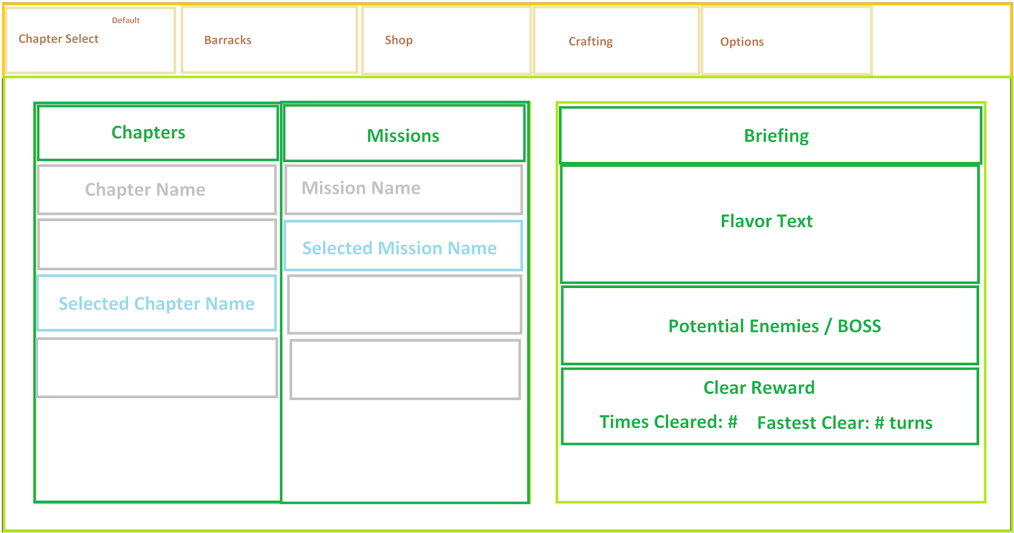

Barracks

